Steps to get the Google Map API Key Value:-
- Go to http://code.google.com/apis/maps/signup.html
- Enter the Your website URL in “My we site URL:” and select the Checkbox for terms and conditions. Refer the Fig 1.0. Then click the Generate API key button.
Fig 1.0
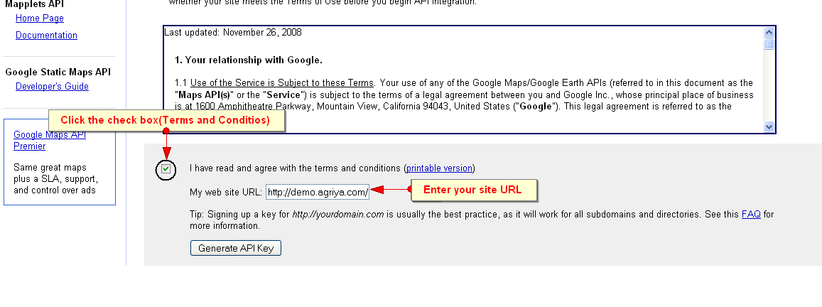
- After that you will get the Google Maps API key value.
Refer Fig 2.0
Fig 2.0
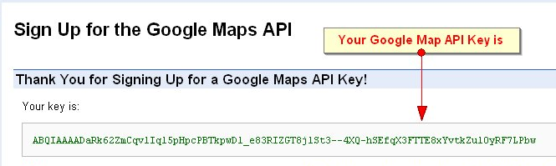

- Copy that key and paste it in the following file loction.
Open the config_photo.inc.php file.
Find the following variable.
$CFG['admin']['photos']['google_map_key'] = '';
Paste that Google API Key.
$CFG['admin']['photos']['google_map_key'] = 'ABQIAAAADaRk62ZmCqvlIql5pHpcPBTkpwDl_e83RIZGT8jlSt3--4XQ-hSEfqX3FTTE8xYvtkZulOyRF7LPbw';

